**Module-2: GIT Assignment – 4**

1. Put master.txt on master branch, stage and commit.





1. Create 3 branches: public1, public2 and private.



3.Put public1.txt on public 1 branch, stage and commit.







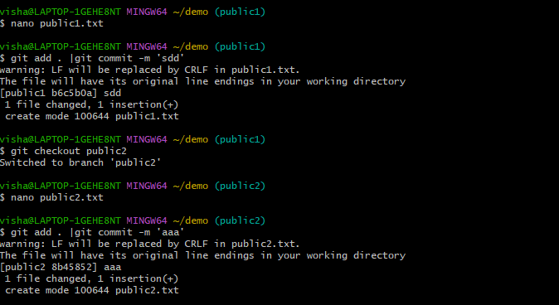

4. Merge public 1 on master branch.

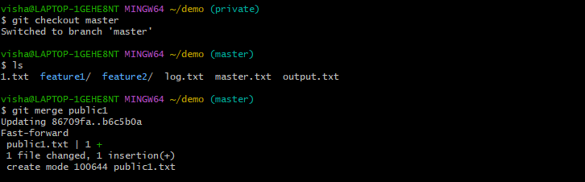

5.Merge public 2 on master branch.





6. Edit master.txt on private branch, stage and commit.

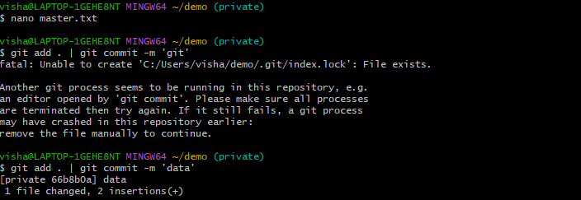

7. Now update branch public 1 and public 2 with new master code in private.

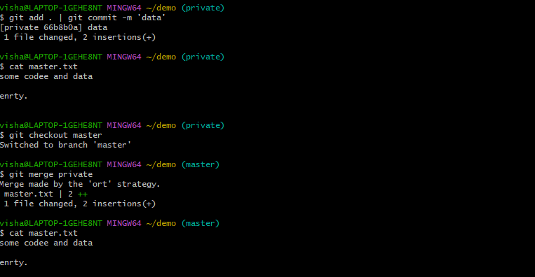

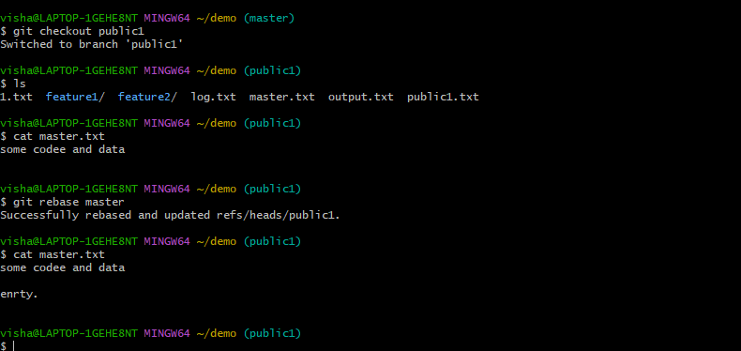

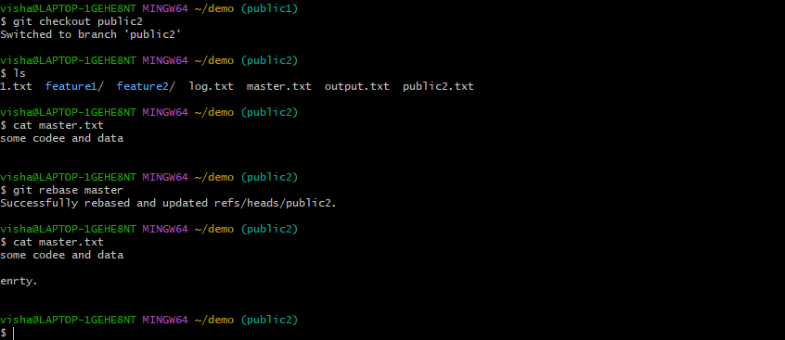

8. Also update new master code on master.

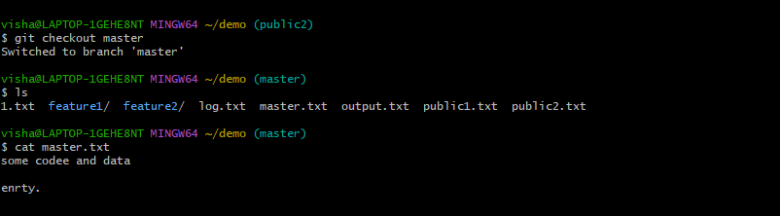

9. Finally update all the code on the private branch

